**JMS integration:**

1. What is Message?
2. What is Messaging?
3. Advantages of Messaging.
4. What is JMS?
5. JMS Vs Email.
6. JMS Application.
7. JMS Component.
8. MOM Service provider.
9. Messaging Models (PTP & Pub/ Sub).
10. JMS API Programming Model.
11. Message Consumption type.
12. Spring JMS integration and Code Sample.
13. JMS Message Type, JMS Features, JNDI, SOAP & Miscellaneous Topic.

**What is Message?**

1. Message is nothing but piece of data or information which is being exchange between two parties or devices. In other word it is an entity of communication.
2. Messages are used to transfer information from one application to another which may or may not run in the same application.

**What is Messaging?**

Transferring of message from one application to another is called messaging i.e. it is communication between system components or different application which are loosely coupled in a distributed environment.

**Note**: TCP Sockets, CORBA or RMI is the tightly coupled.

**Advantages of JMS**

1. Ability to integrate different platform i.e. different platform can talk to each other
2. Increased to scalability and reliability of message delivery.
3. Reduces system bottlenecks

**What is JMS?**

1. It is message oriented **middleware (MOM) (broker or agent)** API for sending messages between two or more clients. It is similar to post office and postman where if someone sent any letter to anybody then there we have one middleware (post office) via which letter is being sent to particular person.
2. It is a specification which is used in the java program to create, send, receive, and read distributed enterprise messages.
3. It provides a loosely coupled communication i.e. it does not matter that who is sender and who is receiver.
4. It provides Asynchronous messaging i.e. it does not matter that whether the sender (client) and receiver (server) is present at the same time or not.
5. It ensures the reliable delivery i.e. a message is guaranteed to be delivered once and only once i.e. message won’t be lost and message will not be delivered more than once.

**JMS Application:**

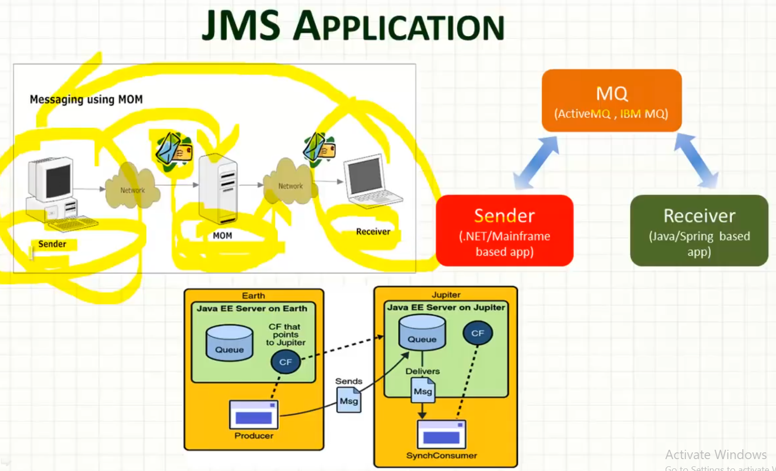

1. The above diagram describes JMS application where a sender sends a message to **middleware (broker) which intern passes the message to network and to the receiver.**
2. The middleware is normally a MQ applications provider which could be ActiveMQ (apache interface) or IBM MQ.
3. Sender and Receiver need not to be same. It could be different platform or application.
4. The sender and receiver both can send and receive the messages to each other back and forth two way communication which are loosely coupled. I.e. sender can become receiver when it receives message and receiver can become sender when it send the messages.
5. Thus it is typical java application which have three major parts:
6. Message oriented middleware (MOM).
7. The sender.
8. The receiver.

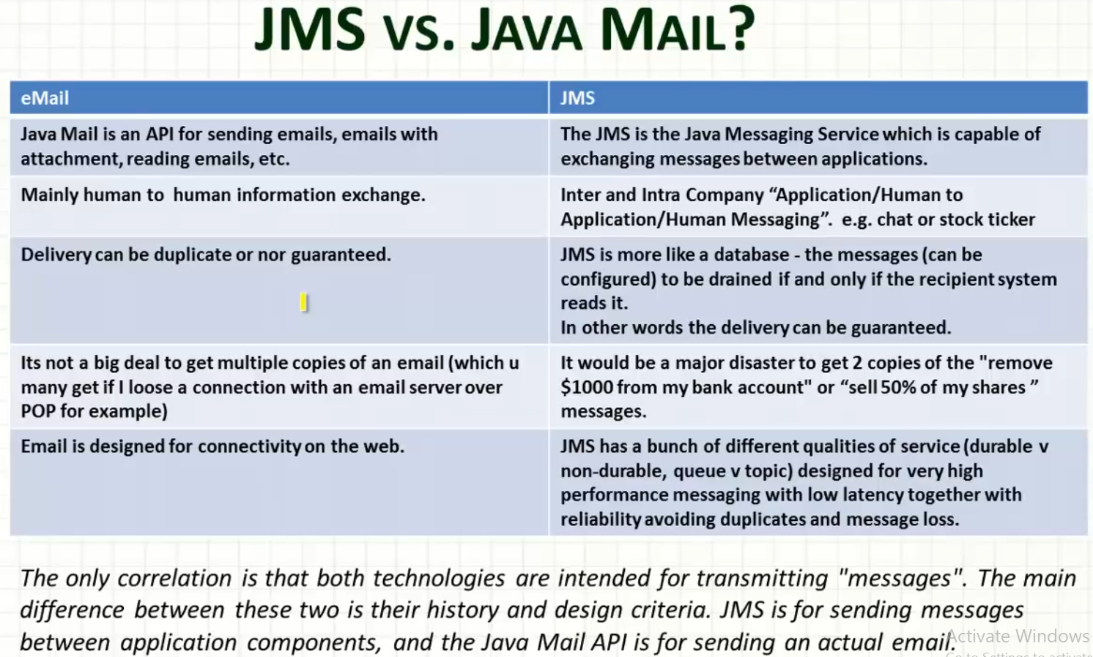

**JMS Components:**

**JMS Providers:** This is the messaging system (MOM) which implements JMS. Like IBM MQ, ActiveMQ.

**JMS Client:** The application that produces or receives messages. There are four types of clients.

1. **JMS Producer / Publisher**: A JMS Client that creates and sends messages.
2. **JMS Consumer/ Subscriber**: A JMS Client that receive messages.

**JMS Application:** IT composed of many JMS clients and one typical JMS provider.

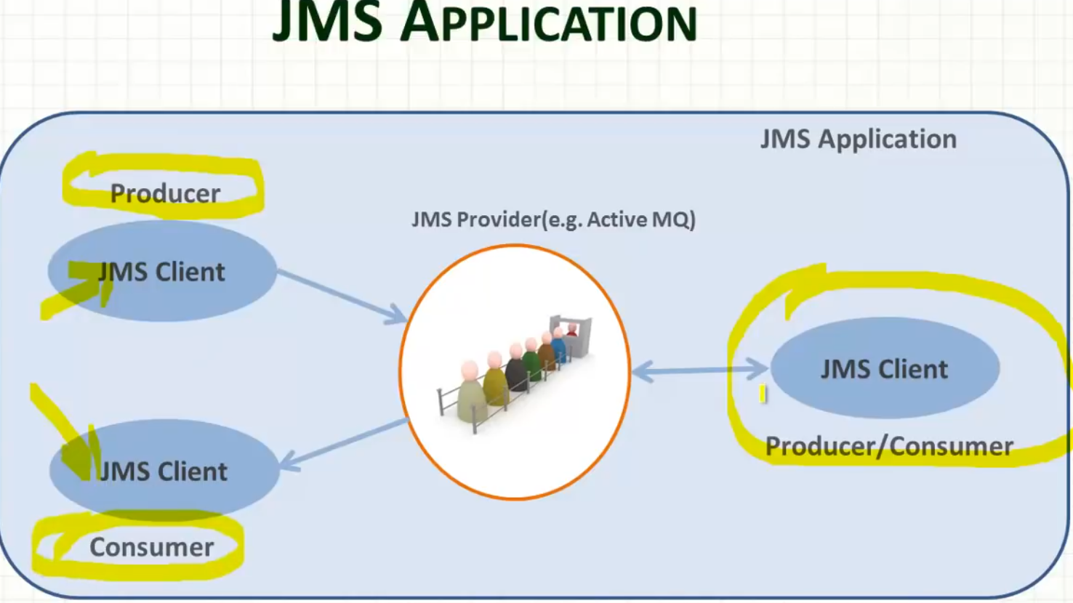

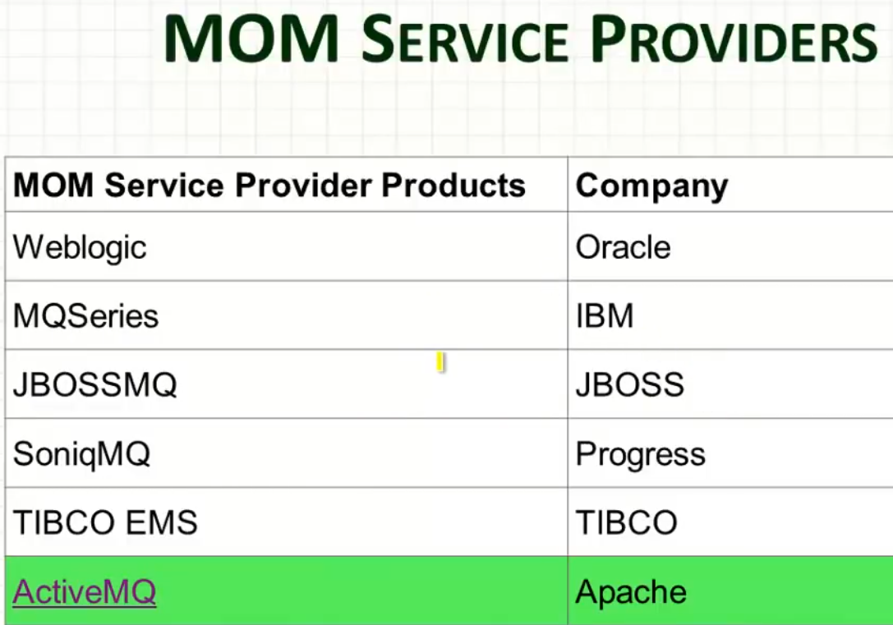

**Messaging Models:**

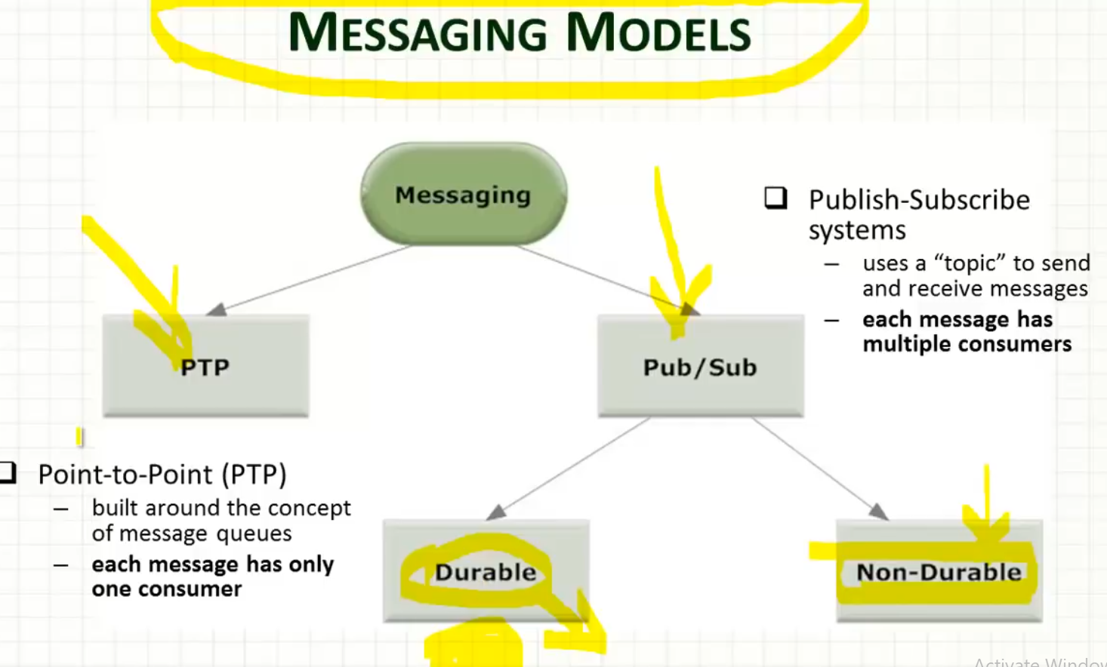

**As we can see that there we have two types of messaging model**

1. **Point-to-Point (PTP) System:** This is built on the concept of message queue (FIFO) and here each message has only one consumer.
2. **Publish-Subscribe system.** This uses “topic” to send and receive messages and each messages can have multiple consumers.
3. **The Publish-Subscribe system can be divided further in two :**
4. **Durable or Persistence:** Here we need to have one database to save publish-Subscribe message.
5. **Non-Durable or Non Persistence:** Here the message can be delivered directly whoever is available in the system.

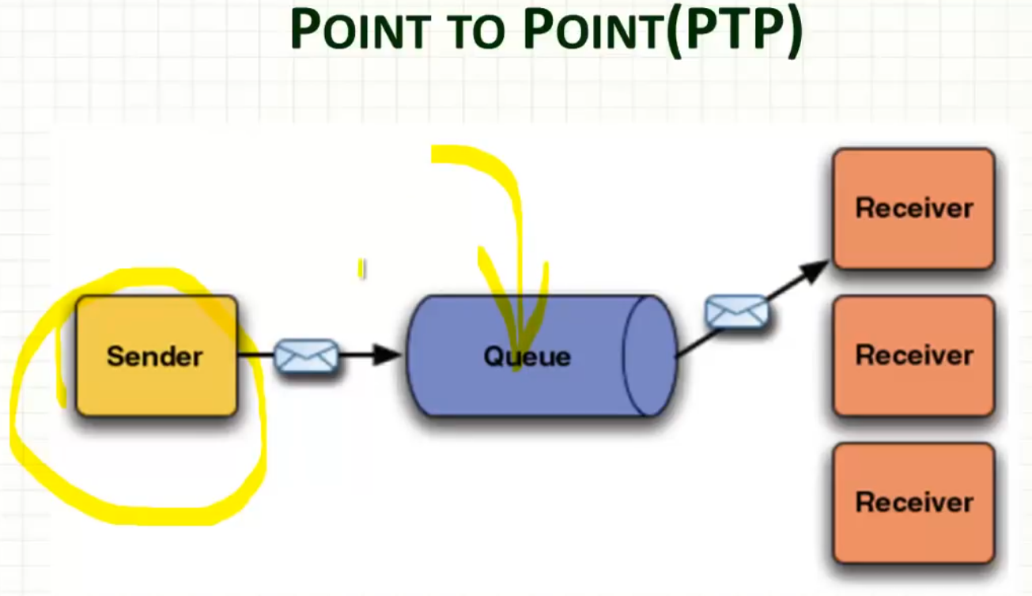 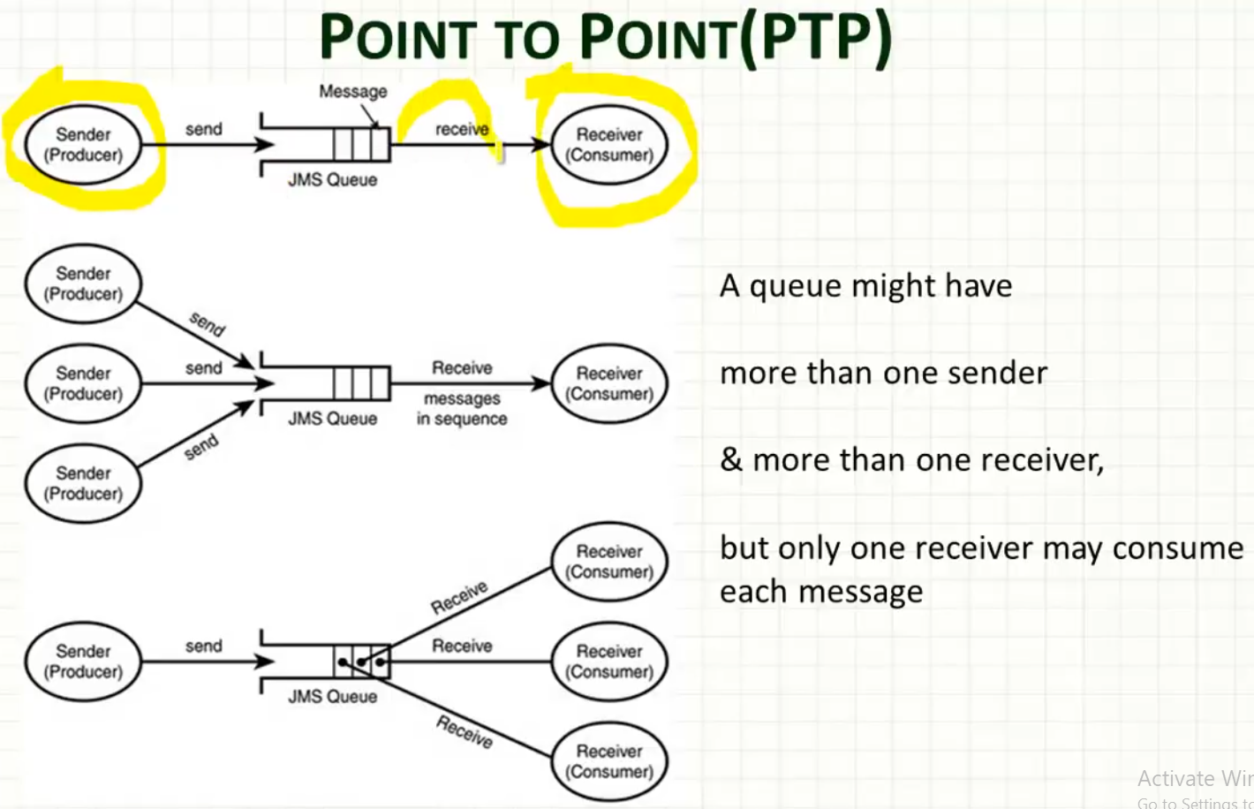

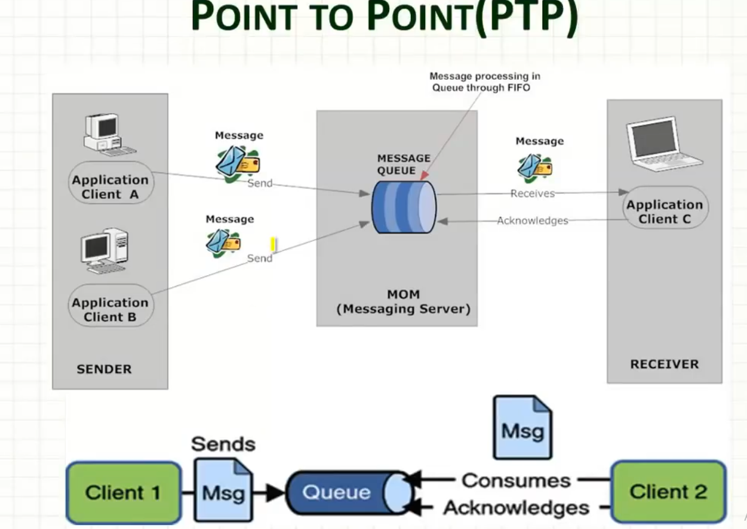

**Explanation**:

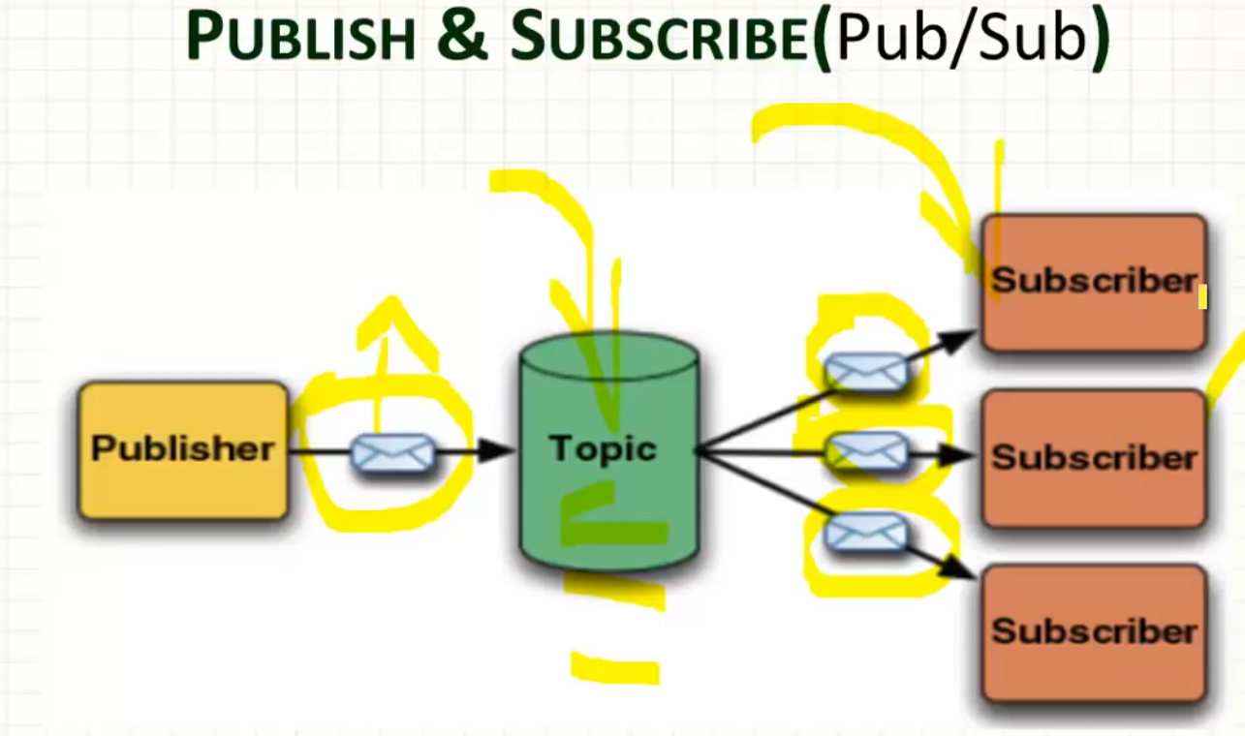

* Here instead of queue we have Topic in the middleware.
* The message send by publisher will be send to all subscriber i.e. a copy of publisher message will be created by topic and will be send to all subscriber just like a newsletter or newspaper.
* Email is the example of PTP and NEWS letter or paper is an example of Publish-Subscribe.

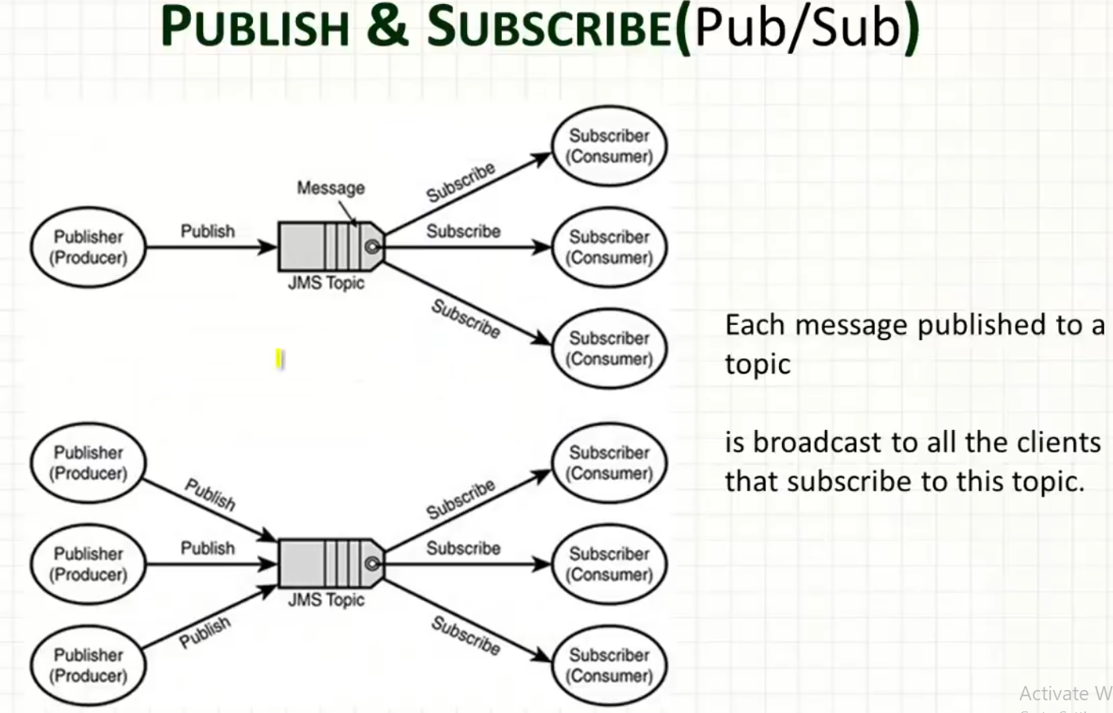

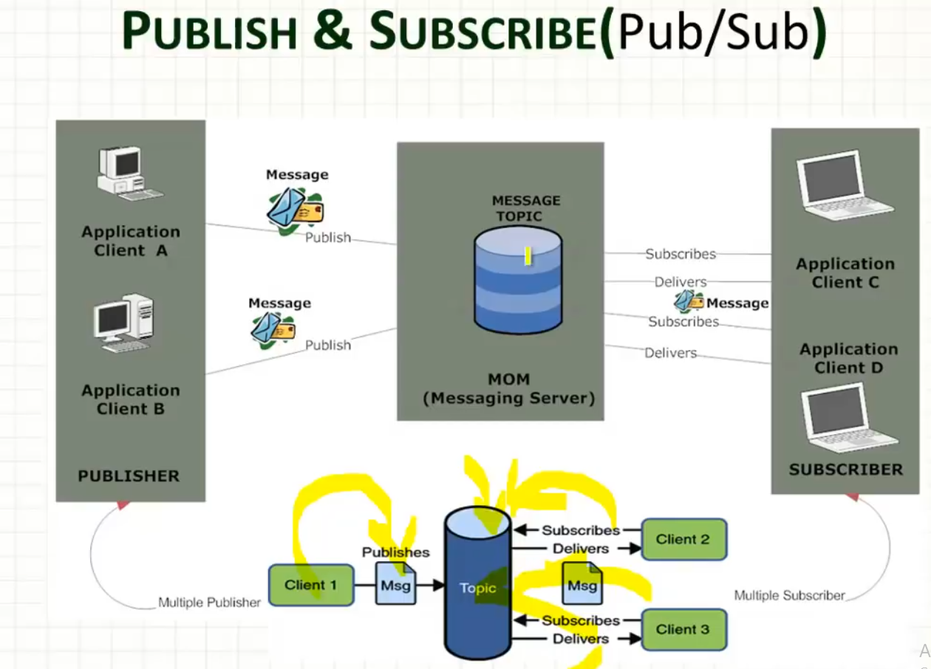

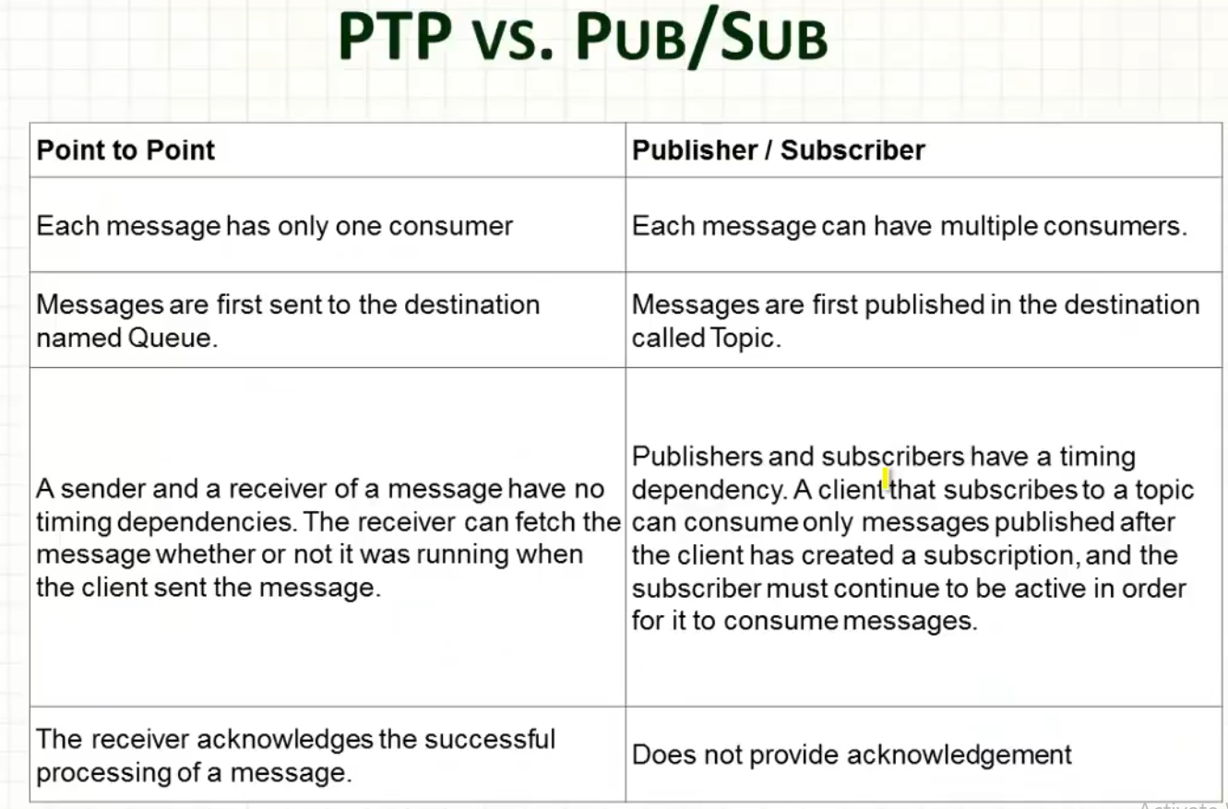

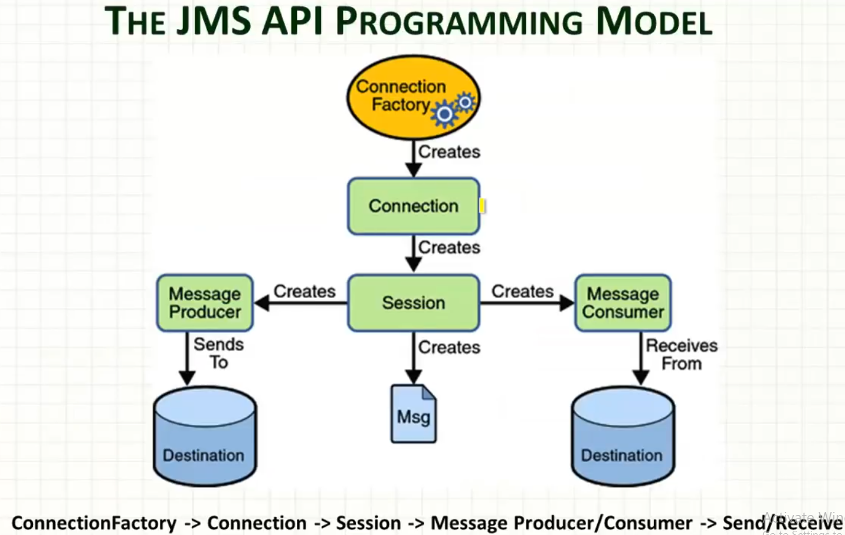

**Programming sequence to create JMS Cleint**

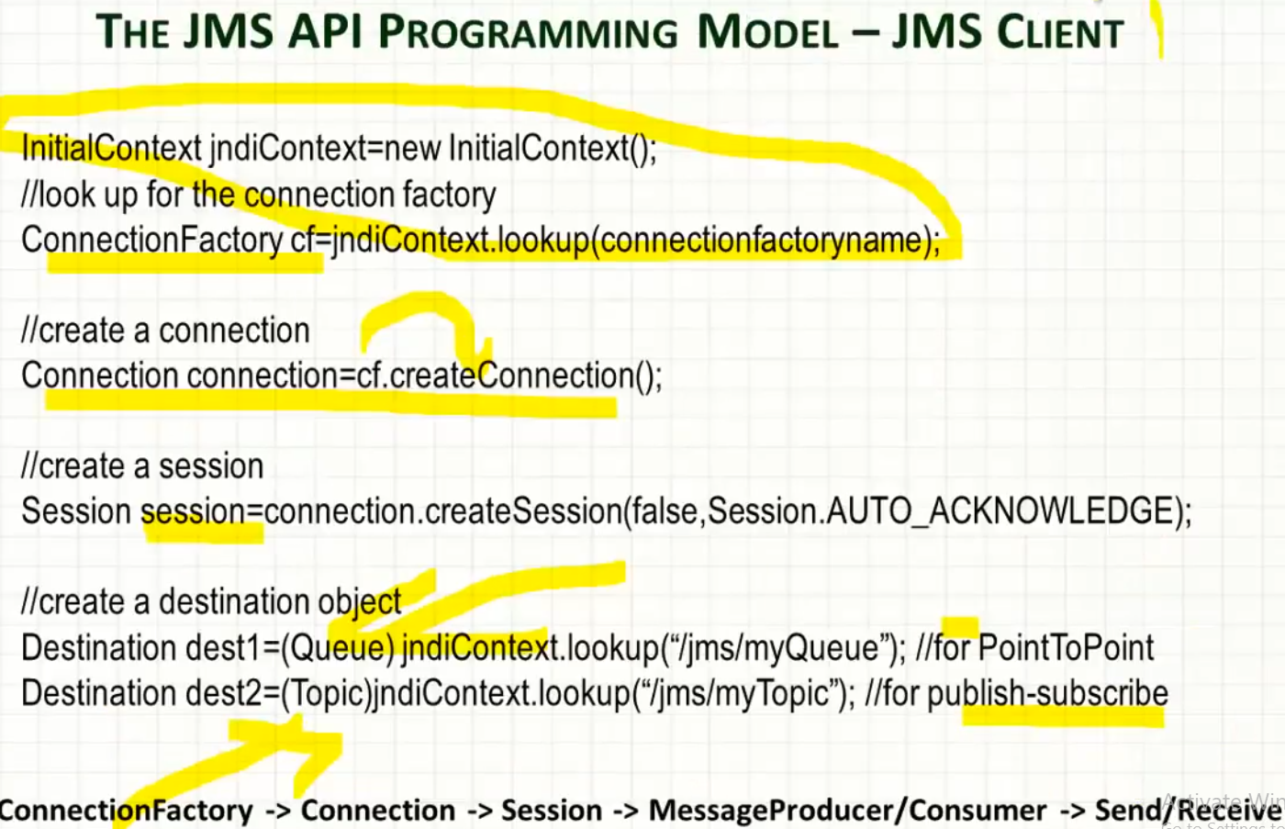

**Programming sequence to create JMS Producer**

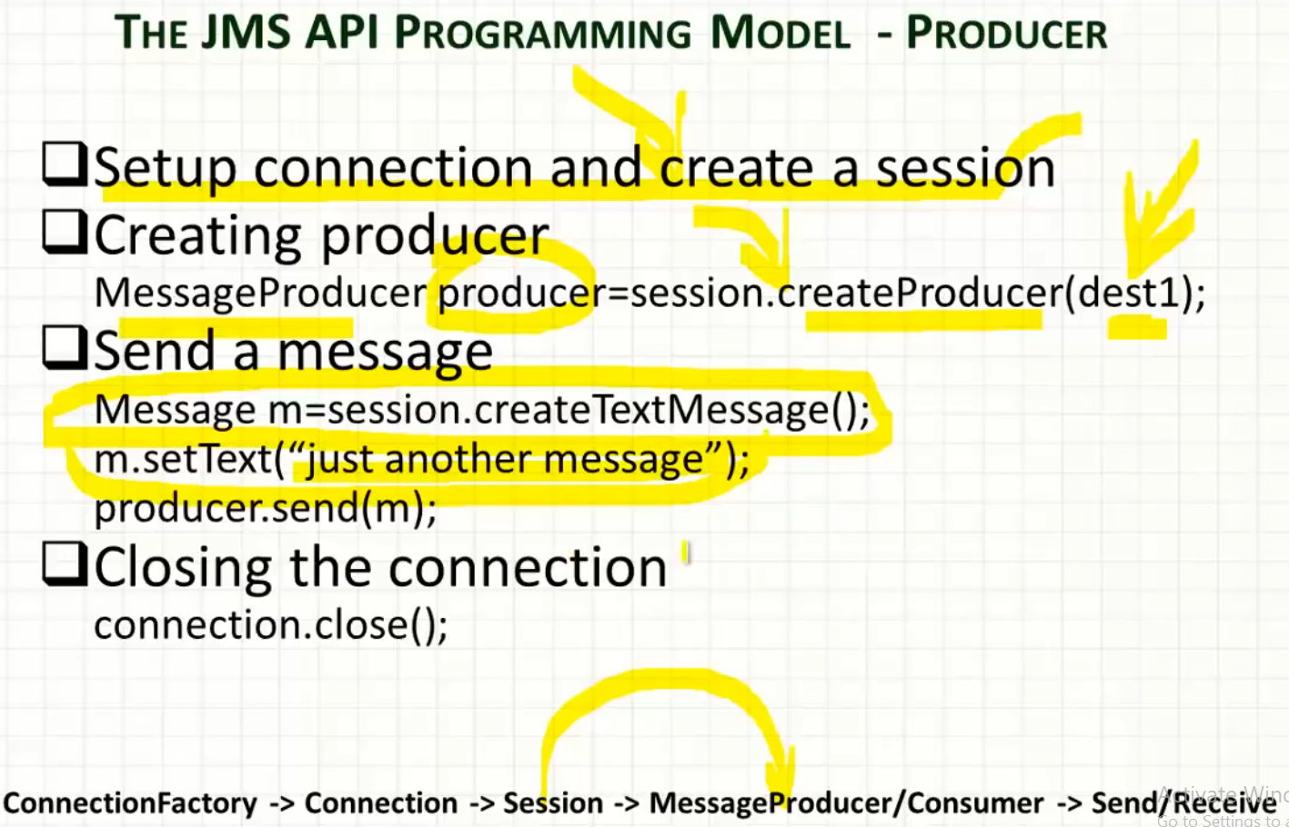

**Programming sequence to create JMS Consumer: For Synchronous message**

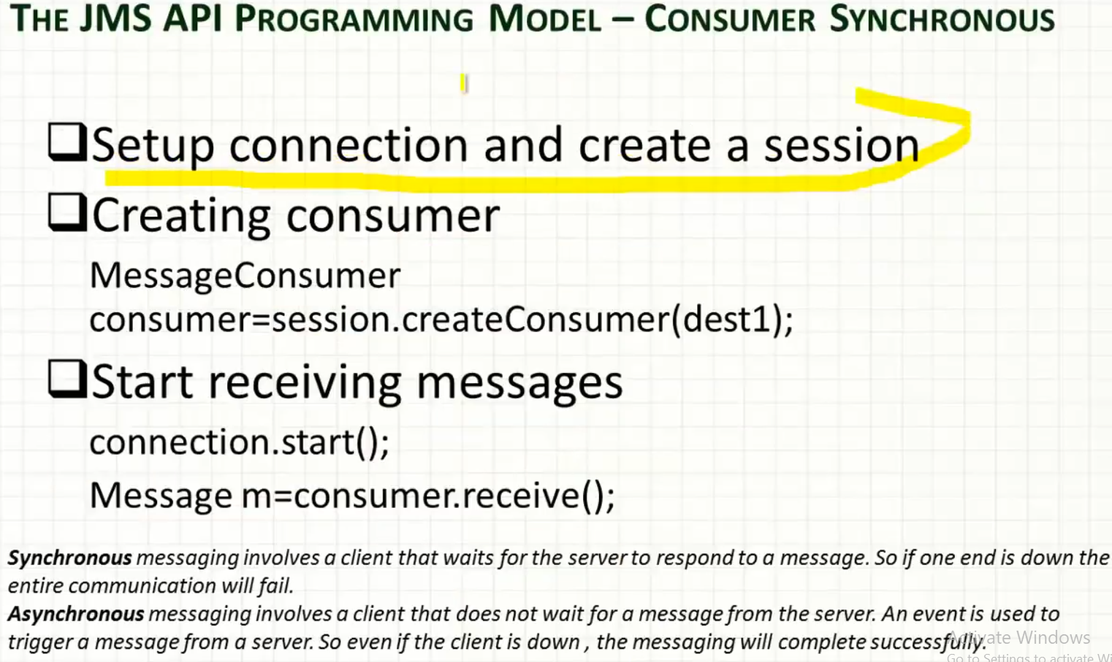

**Programming sequence to create JMS Consumer: For Asynchronous message**

